
VIVEKANANDA INSTITUTE OF PROFESSIONAL STUDIES - TECHNICAL CAMPUS
Grade A++ Accredited Institution by NAAC
NBA Accredited for MCA Programme; Recognized under Section 2(f) by UGC; Affiliated to GGSIP University, Delhi; Recognized by Bar Council of India and AICTE An ISO 9001:2015 Certified Institution

SCHOOL OF ENGINEERING & TECHNOLOGY
B.Tech Programme: Computer Science & Engineering

Course Title: Data Warehousing Data Mining Lab Course Code: CIE-425P

Semester: 7th

Submitted By:
Name: Aneesh Khanna
Enrollment No: 35117702722 Branch & Section: CSE-B (G2)

An ISO 9001:2015 Certified Institution
SCHOOL OF ENGINEERING & TECHNOLOGY

VIVEKANANDA INSTITUTE OF PROFESSIONAL STUDIES - TECHNICAL CAMPUS
Grade A++ Accredited Institution by NAAC
NBA Accredited for MCA Programme; Recognized under Section 2(f) by UGC; Affiliated to GGSIP University, Delhi; Recognized by Bar Council of India and AICTE

VISION OF INSTITUTE

To be an educational institute that empowers the field of engineering to build a sustainable future by providing quality education with innovative practices that supports people, planet and profit.
MISSION OF INSTITUTE
To groom the future engineers by providing value-based education and awakening students' curiosity, nurturing creativity and building capabilities to enable them to make significant contributions to the world.

EXPERIMENT 1

Aim: Study of ETL process and its tools.

Theory:

Dataset:

Program:
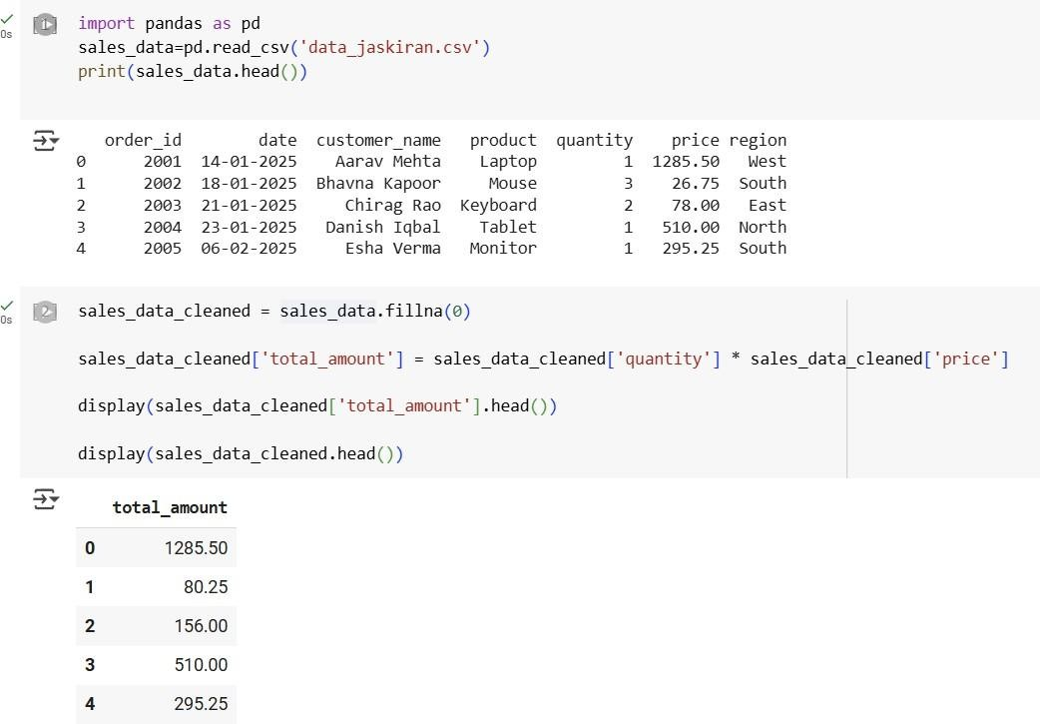
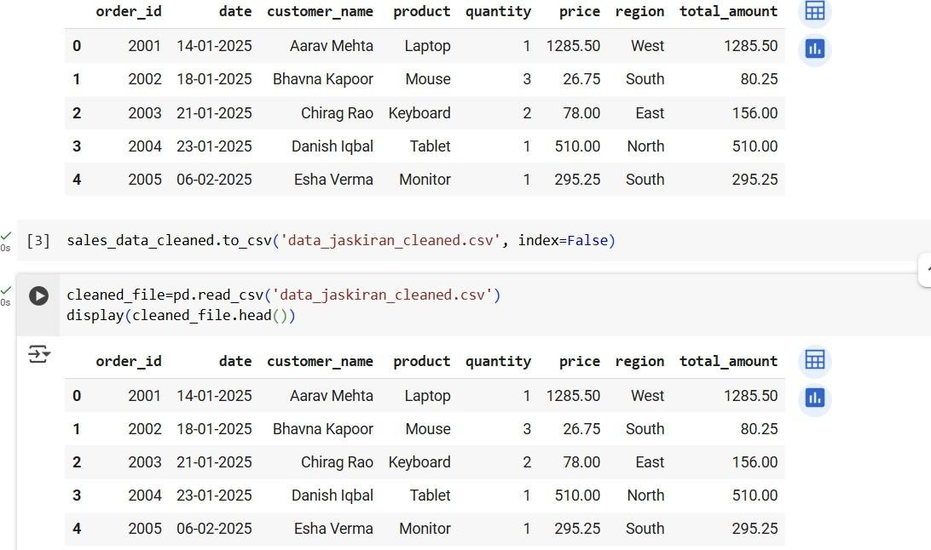
Learning Outcomes:

EXPERIMENT 2

Aim: Program of Data warehouse cleansing to input names from users (inconsistent) and format them.
Theory:

Dataset:

Program:
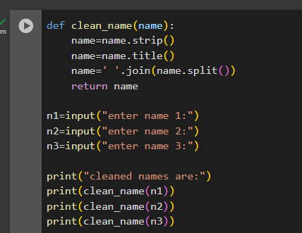

Output:
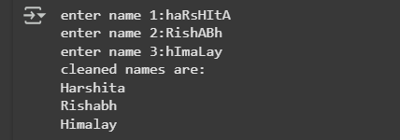

Learning Outcomes:

EXPERIMENT 3

Aim: Program of Data warehouse cleansing to remove redundancy in data.

Theory:

Dataset:

Program:
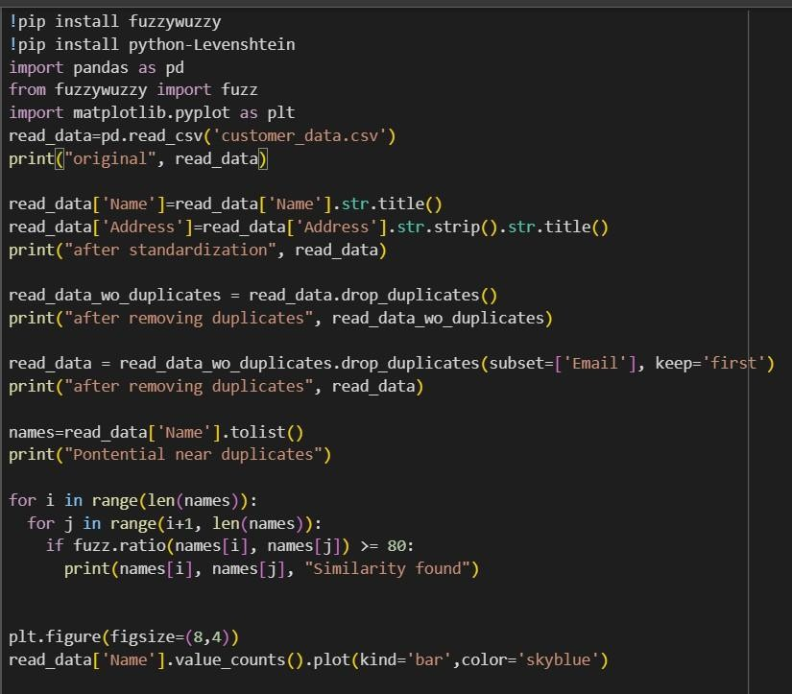

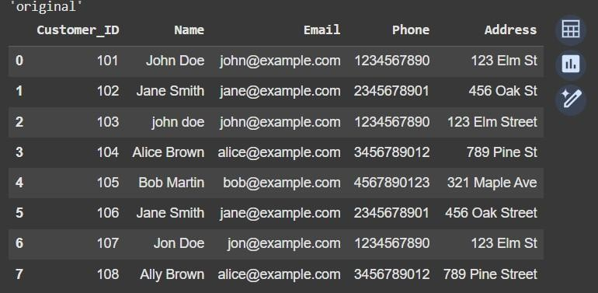
Output:

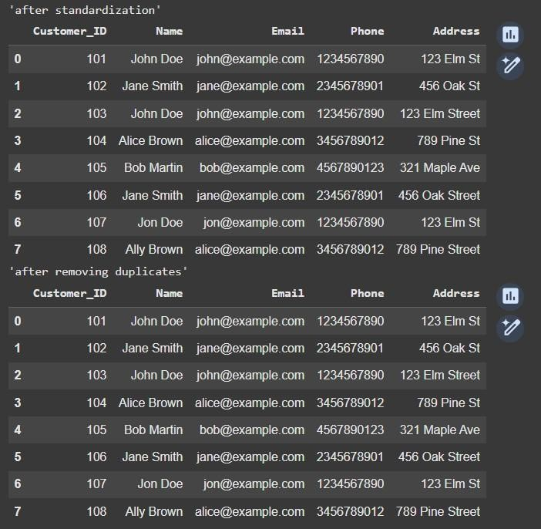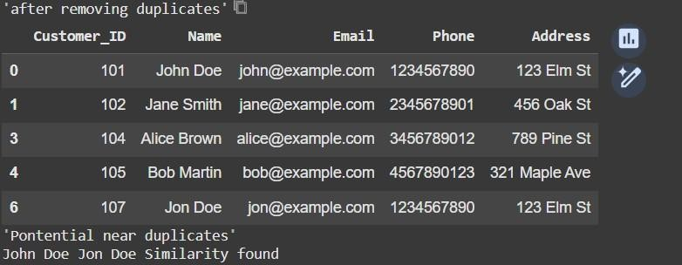

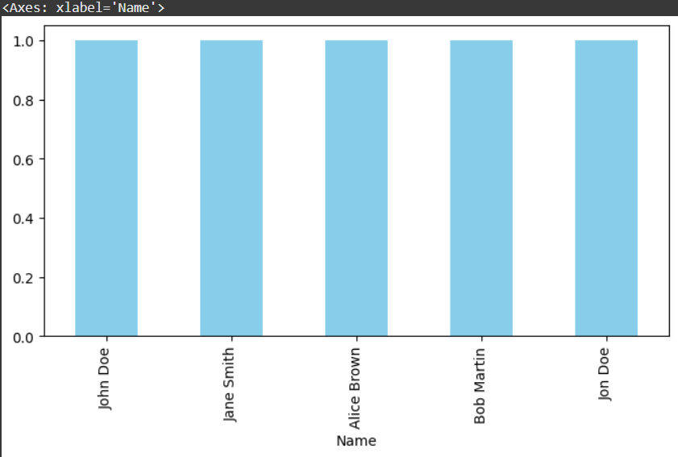
Learning Outcomes:

EXPERIMENT 4

Aim: Introduction to WEKA tool

Theory:

Dataset:


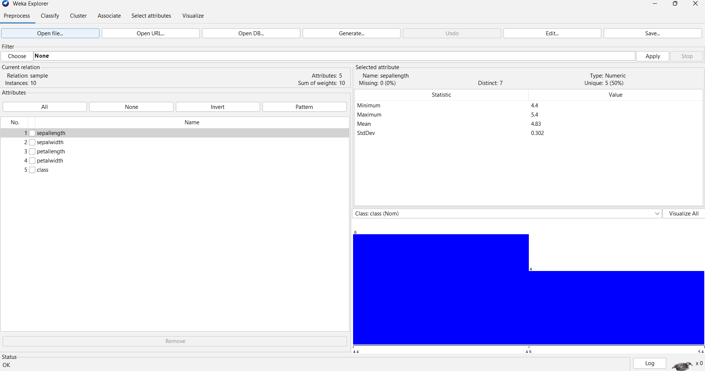
WEKA :

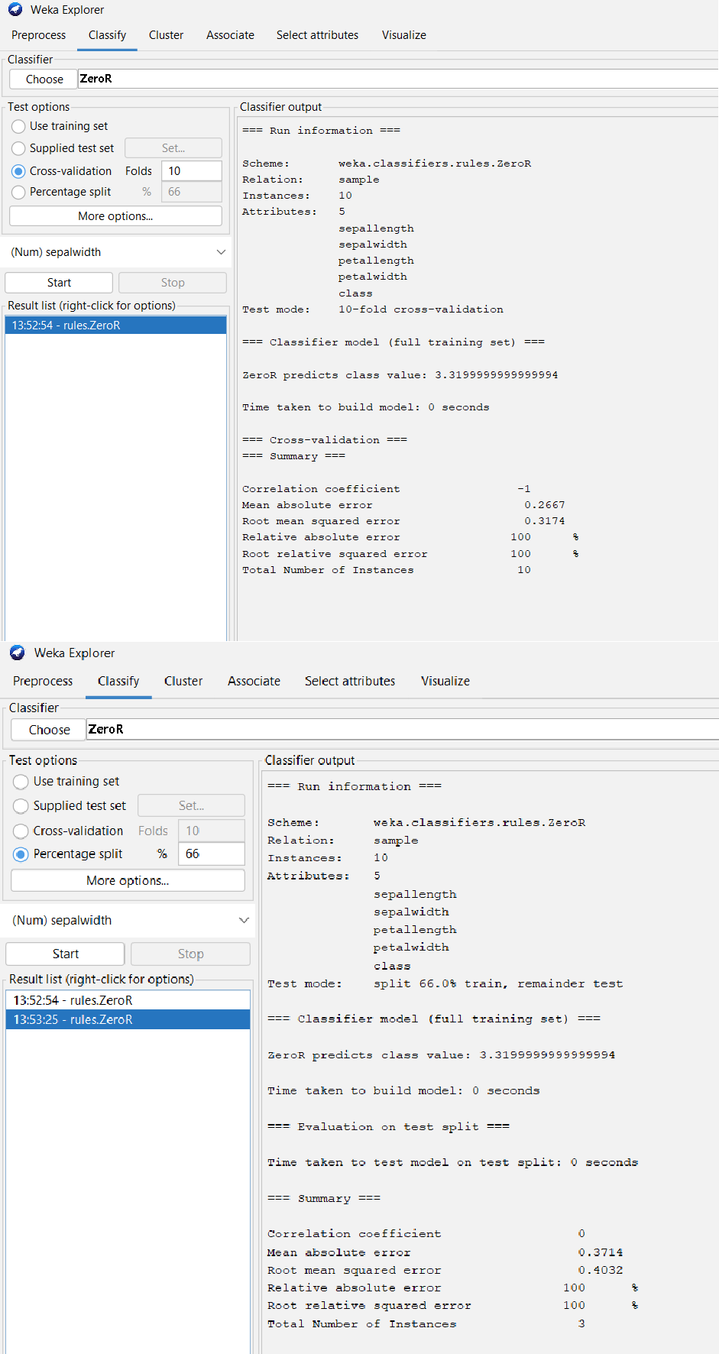

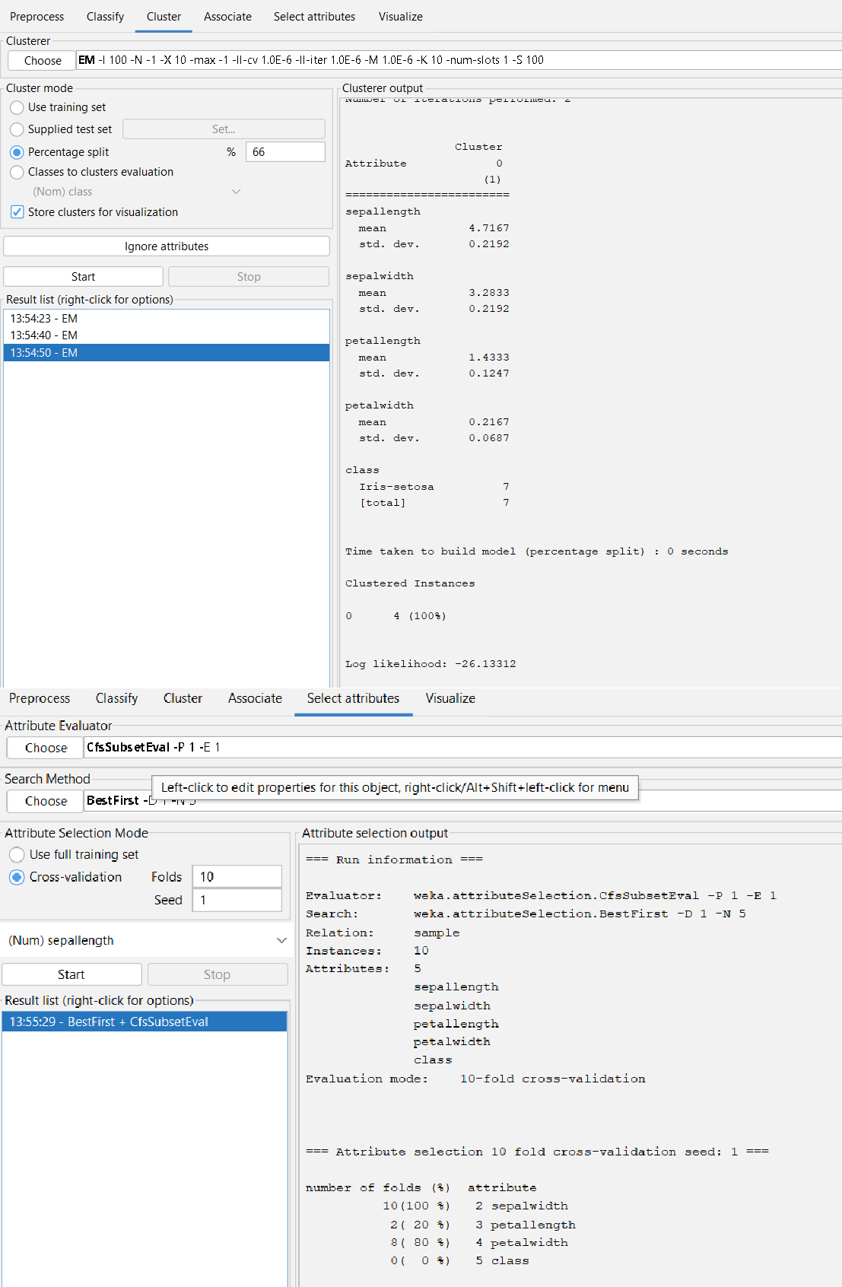

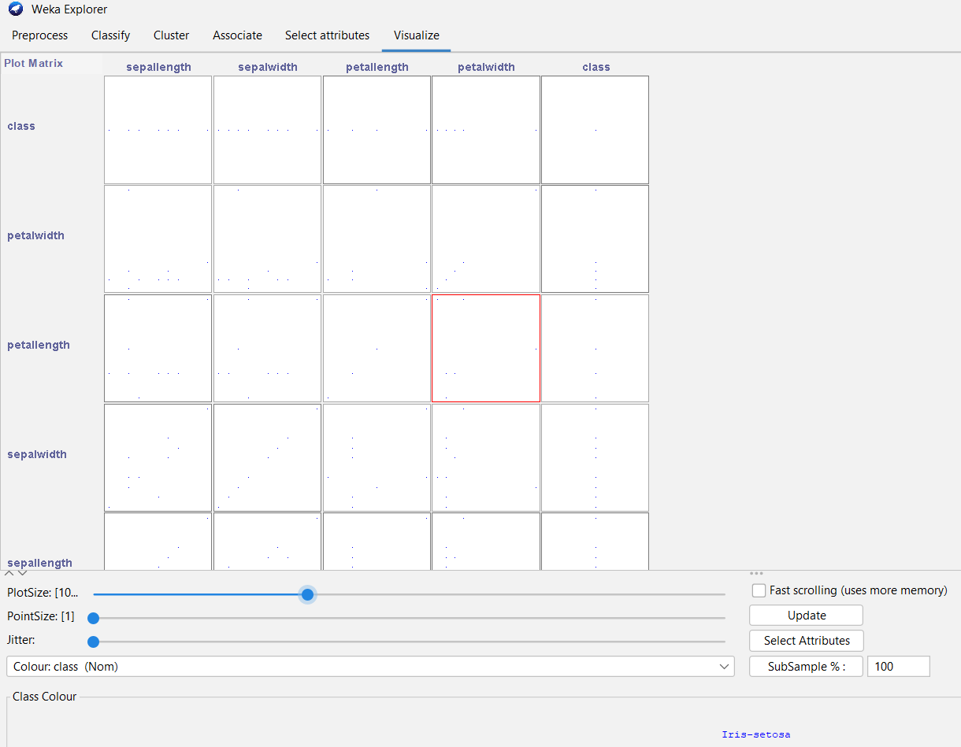

Learning Outcomes:

EXPERIMENT 5

Aim: Implementation of Classification technique on ARFF files using WEKA

Theory:

Dataset:

WEKA :

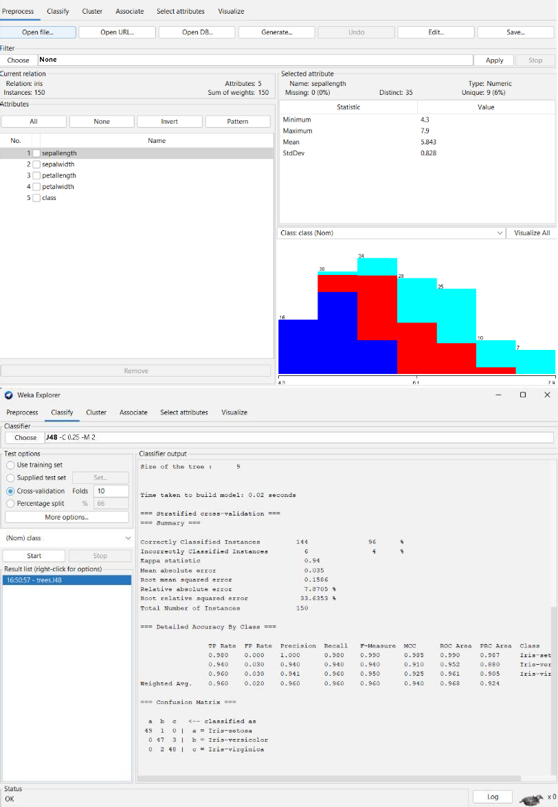

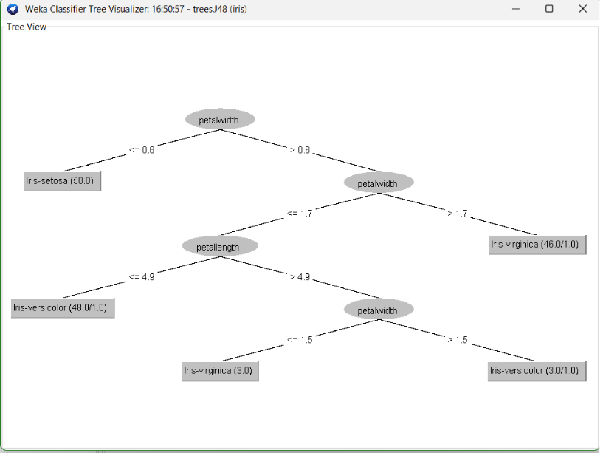

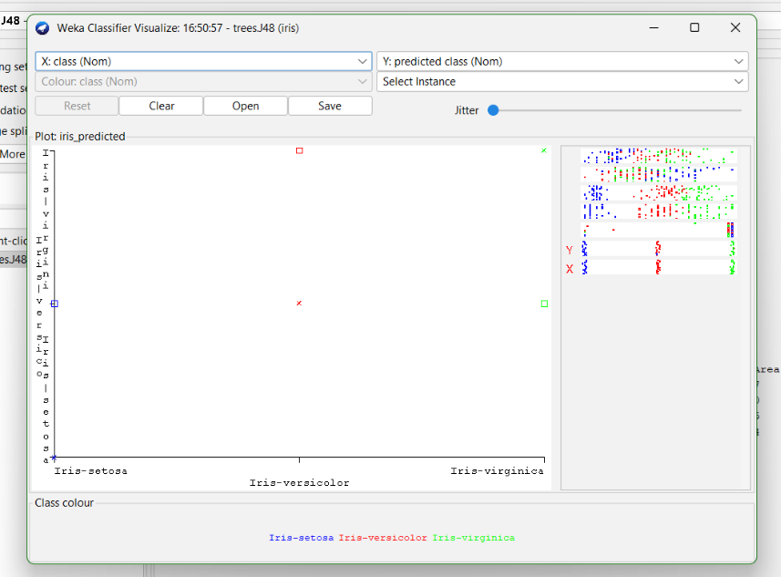
Learning Outcomes:

EXPERIMENT 6

Aim: Implementation of Clustering technique on ARFF files using WEKA.

Theory:

Dataset:

WEKA :
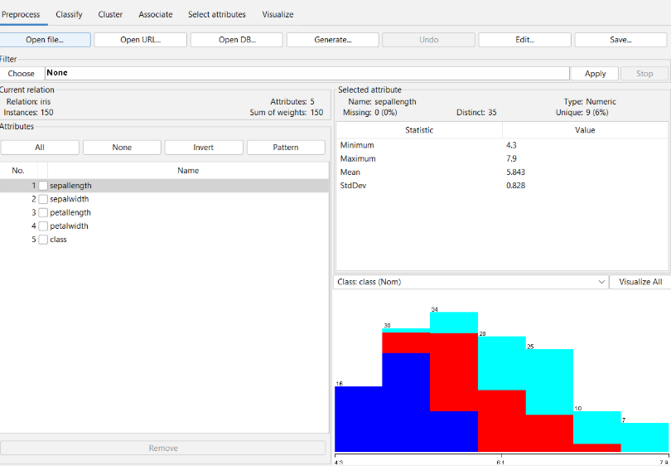
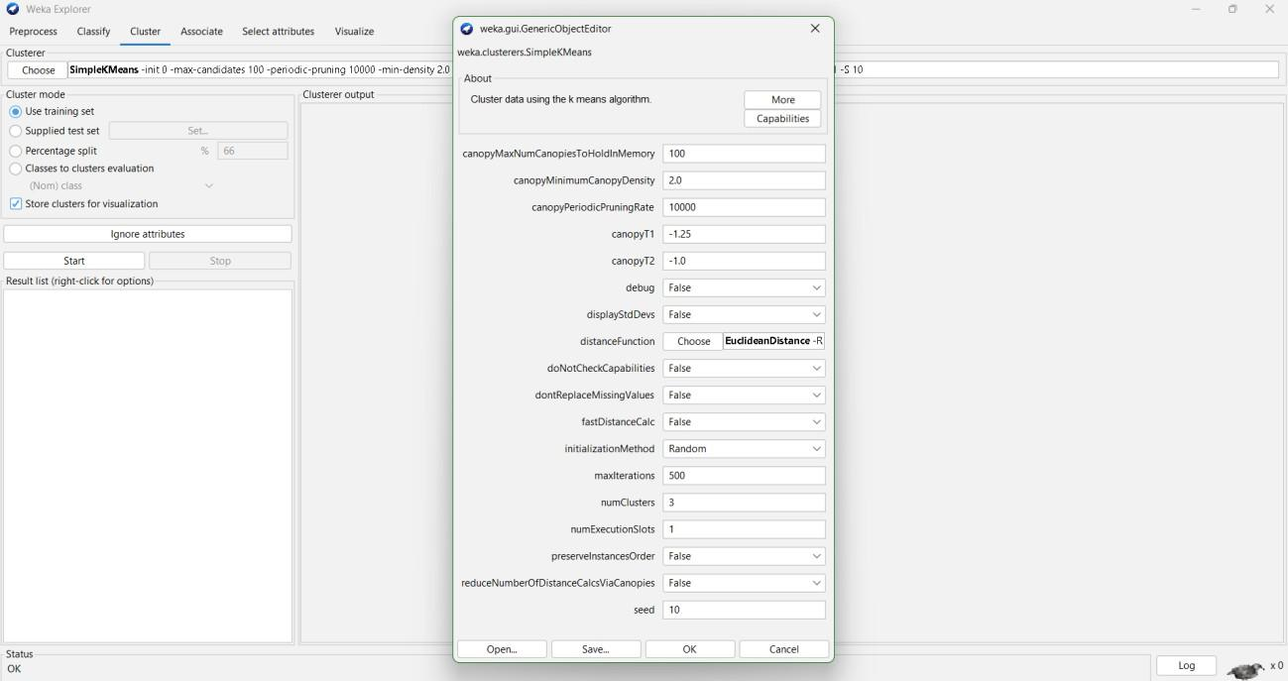

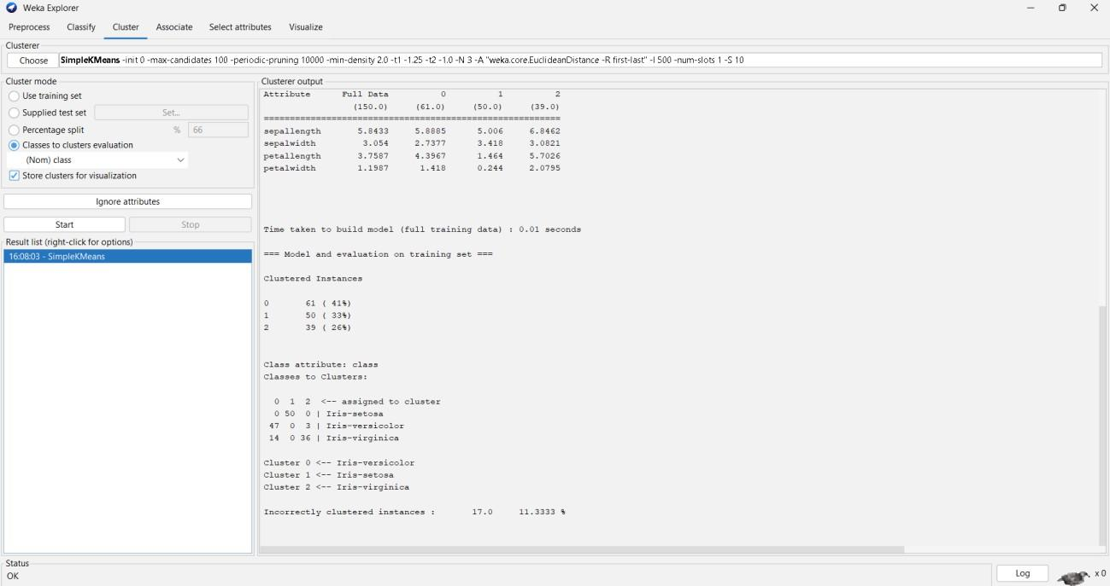
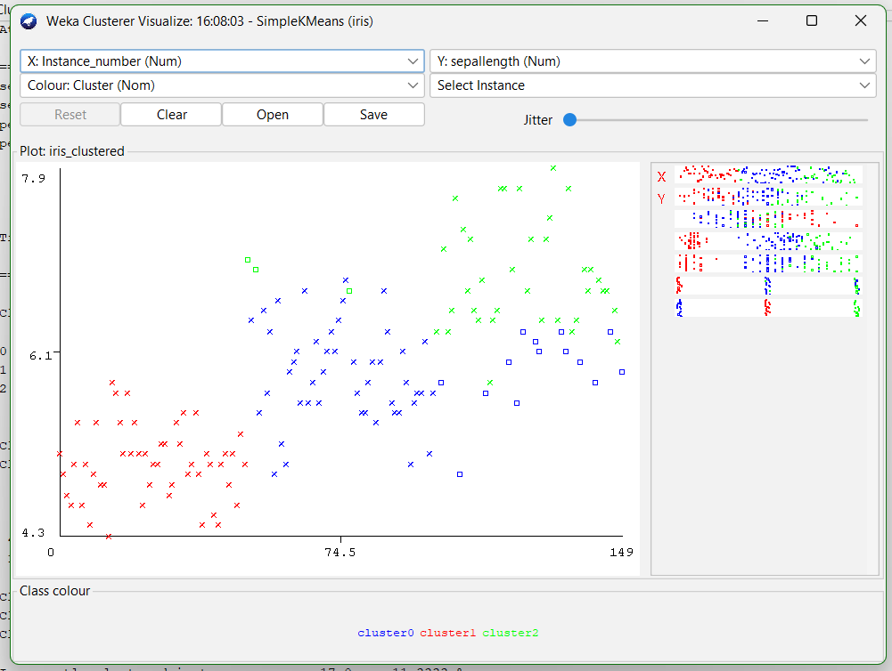
Learning Outcomes:

EXPERIMENT 7

Aim: Implementation of Association Rule technique on ARFF files using WEKA.

Theory:

Dataset:

WEKA :
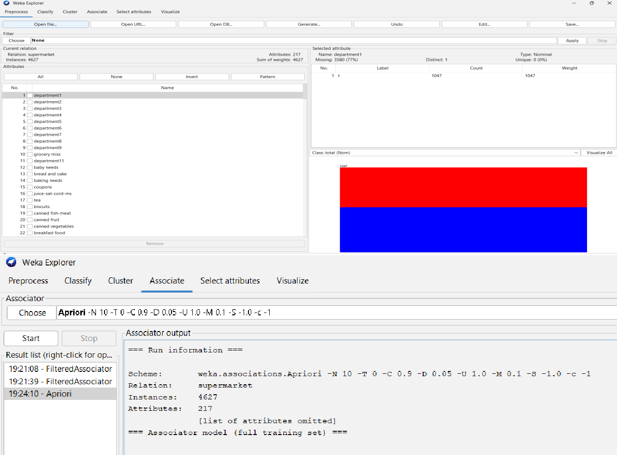
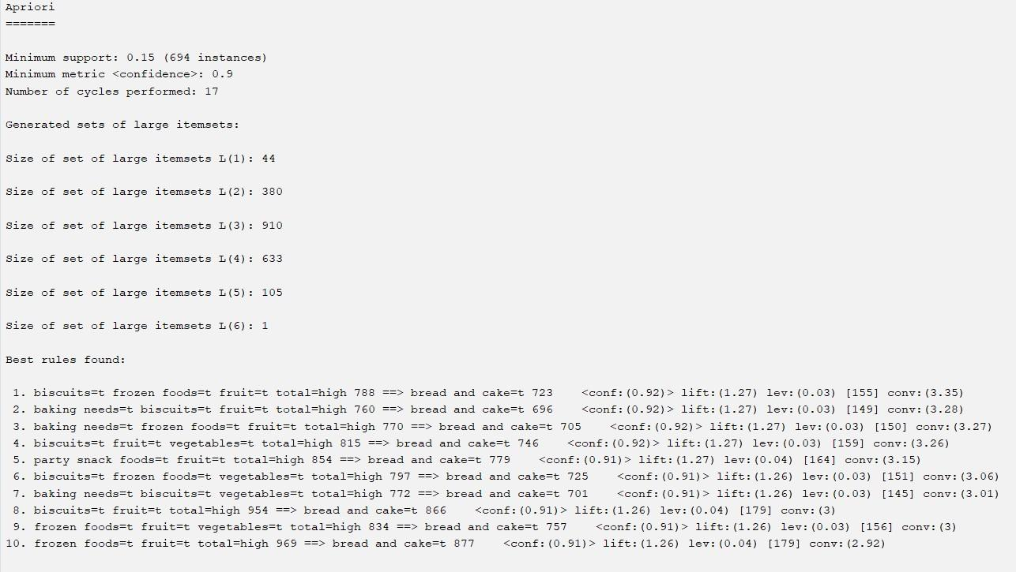
Learning Outcomes:

EXPERIMENT 8

Aim: Implementation of Visualization technique on ARFF files using WEKA.

Theory:

Dataset:

WEKA :
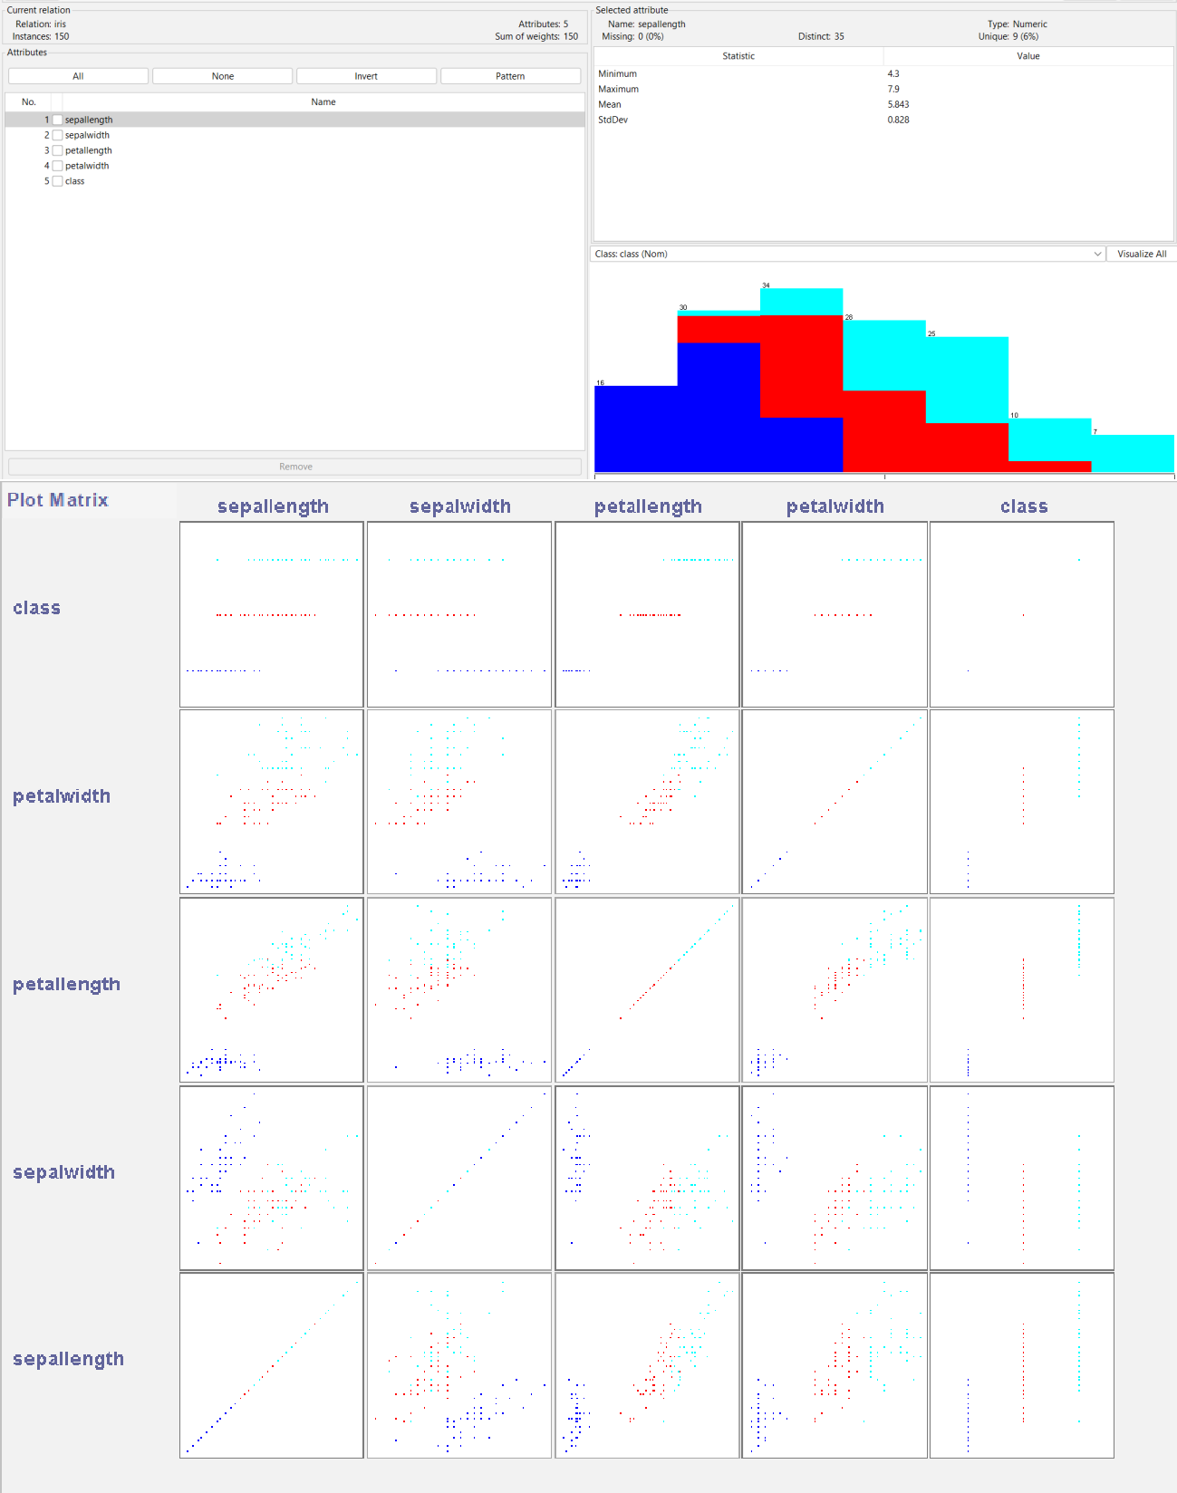
Learning Outcomes:

EXERCISE 1

Aim: Apply the Apriori Algorithm focusing on discriminating between patients with Parkinson’s disease and other neurological disorders using the Voice Recording Dataset.
Theory:

Dataset:

Code:

import warnings, gc, io
warnings.filterwarnings('ignore')

!pip install pandas mlxtend

import pandas as pd

url = "https://archive.ics.uci.edu/ml/machine-learning-databases/parkinsons/parkinsons.data"
df = pd.read_csv(url)
df.head()

# Drop name column
df = df.drop("name", axis=1)

# Convert status column into labels
df['status'] = df['status'].map({0: "Healthy", 1: "Parkinsons"})

# Binning continuous features
for col in df.columns:
if col != "status":
df[col] = pd.qcut(df[col], q=3, labels=['Low', 'Medium', 'High'])

from mlxtend.preprocessing import TransactionEncoder

# Convert df to list of lists (transactions)
transactions = []
for i in range(len(df)):
row_items = []
for col in df.columns:
row_items.append(f"{col}={df[col].iloc[i]}")
transactions.append(row_items)

# Transaction Encoder
te = TransactionEncoder()
te_ary = te.fit(transactions).transform(transactions)

df_encoded = pd.DataFrame(te_ary, columns=te.columns_)
df_encoded.head()

from mlxtend.frequent_patterns import apriori, association_rules

# find frequent itemsets
freq_items = apriori(df_encoded, min_support=0.3, use_colnames=True)
freq_items.sort_values(by="support", ascending=False).head()

rules = association_rules(freq_items, metric="confidence", min_threshold=0.7)

# Filter rules predicting Parkinson's disease
rules_pd = rules[rules['consequents'].astype(str).str.contains("status=Parkinsons")]

rules_pd.sort_values(by="confidence", ascending=False).head(10)

print("\nAssociation Rules Predicting Parkinson's Disease:\n")
display(rules_pd[['antecedents','consequents','support','confidence','lift']])

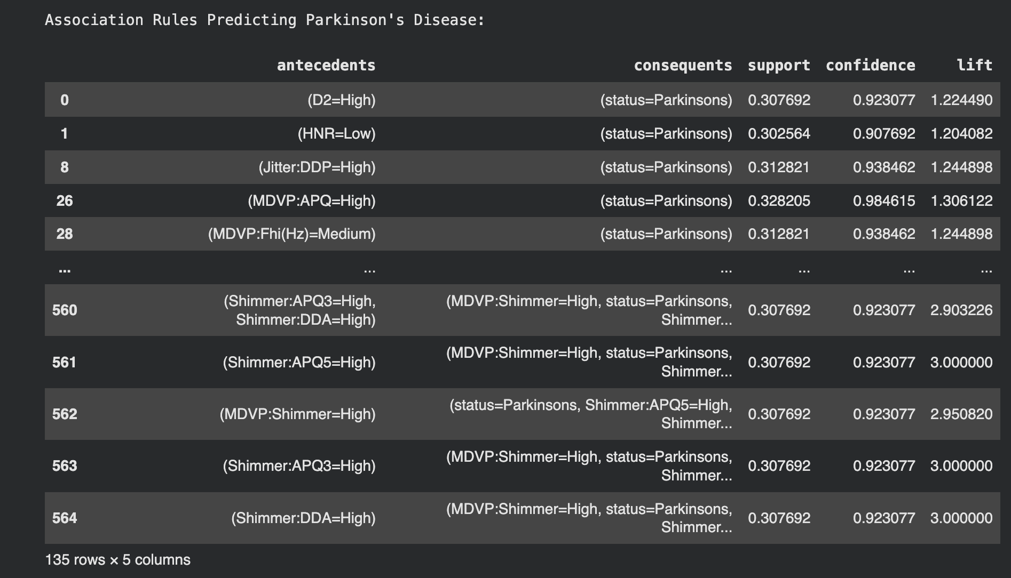
Output:

Learning Outcomes :

EXERCISE 2

Aim: Implement the K-Means Clustering and K-Nearest Neighbors (KNN) algorithms on the Parkinson’s Disease Voice Recording Dataset from the UCI Machine Learning Repository. Perform classification and clustering of patients based on their vocal features, analyze clustering results, evaluate classification accuracy, and compare the performance of both methods.
Theory:

Dataset:

Code:

# Install required libraries
!pip install scikit-learn pandas numpy matplotlib seaborn -q

import pandas as pd
import numpy as np
import matplotlib.pyplot as plt
import seaborn as sns
from sklearn.model_selection import train_test_split, cross_val_score
from sklearn.preprocessing import StandardScaler
from sklearn.cluster import KMeans
from sklearn.neighbors import KNeighborsClassifier
from sklearn.metrics import (classification_report, accuracy_score,
silhouette_score, adjusted_rand_score,
confusion_matrix) # Added confusion_matrix
from sklearn.decomposition import PCA # Added PCA
import warnings
warnings.filterwarnings('ignore')
print("\n Parkinson's Analysis: K-Means & KNN")

# LOAD & PREPROCESS DATA
try:
# Load from direct URL
url = "https://archive.ics.uci.edu/ml/machine-learning-databases/parkinsons/parkinsons.data"
df = pd.read_csv(url)

y = df['status'].values # 1 = Parkinson's, 0 = Healthy
X = df.drop(['name', 'status'], axis=1)
print(f"Dataset loaded: {X.shape[0]} samples, {X.shape[1]} features")
except Exception as e:
print(f"Error loading data: {e}")
exit()

# Split data for supervised learning (KNN)
X_train, X_test, y_train, y_test = train_test_split(
X, y, test_size=0.2, random_state=42, stratify=y
)

# Feature Scaling
scaler = StandardScaler()
X_scaled = scaler.fit_transform(X) # For K-Means (all data)
X_train_scaled = scaler.fit_transform(X_train) # For KNN (train)
X_test_scaled = scaler.transform(X_test) # For KNN (test)
print("Data split and standardized")

# Apply PCA for visualization (fit on all scaled data)
pca = PCA(n_components=2)

X_pca = pca.fit_transform(X_scaled)
print("PCA applied for visualization")

# K-MEANS CLUSTERING (UNSUPERVISED)
print("\nK-Means Clustering (k=2)")

# Apply K-Means with K=2 (since we know there are 2 classes)
kmeans_2 = KMeans(n_clusters=2, random_state=42, n_init=10)
cluster_labels = kmeans_2.fit_predict(X_scaled)

# Clustering Evaluation Metrics
sil_score = silhouette_score(X_scaled, cluster_labels)
ari_score = adjusted_rand_score(y, cluster_labels) # Compare clusters to true labels

print(f"Silhouette Score: {sil_score:.4f}")
print(f"Adjusted Rand Index (ARI): {ari_score:.4f} (vs true labels)")

# K-NEAREST NEIGHBORS (SUPERVISED)
print("\nK-Nearest Neighbors (KNN)")

# Find optimal K for KNN using cross-validation
k_values = range(1, 20, 2)
cv_scores = []
for k in k_values:
knn = KNeighborsClassifier(n_neighbors=k)
scores = cross_val_score(knn, X_train_scaled, y_train, cv=5, scoring='accuracy')
cv_scores.append(scores.mean())

# Get the best K
optimal_k = k_values[np.argmax(cv_scores)]
print(f"Optimal K found: {optimal_k} (CV Accuracy: {max(cv_scores):.4f})")

# Train KNN with optimal K
knn_optimal = KNeighborsClassifier(n_neighbors=optimal_k)
knn_optimal.fit(X_train_scaled, y_train)

# Predictions
y_pred_test = knn_optimal.predict(X_test_scaled)

# Evaluation
test_accuracy = accuracy_score(y_test, y_pred_test)

print(f"\nKNN Test Accuracy (k={optimal_k}): {test_accuracy:.4f}")
print(f"Classification Report (Test Set):")
print(classification_report(y_test, y_pred_test,
target_names=['Healthy', "Parkinson's"]))

# VISUALIZATION
print("\nVisualizations")

fig, axes = plt.subplots(2, 2, figsize=(14, 12))
fig.suptitle('K-Means vs. KNN Analysis on Parkinson\'s Data', fontsize=16)

# --- Plot 1: K-Means Clustering (PCA) ---
ax1 = axes[0, 0]
ax1.scatter(X_pca[cluster_labels == 0, 0], X_pca[cluster_labels == 0, 1], c='blue', label='Cluster 0', alpha=0.6)
ax1.scatter(X_pca[cluster_labels == 1, 0], X_pca[cluster_labels == 1, 1], c='red', label='Cluster 1', alpha=0.6)
ax1.set_title('K-Means Clustering (PCA Projection)')
ax1.set_xlabel('Principal Component 1')
ax1.set_ylabel('Principal Component 2')
ax1.legend()
ax1.grid(True, alpha=0.3)

# --- Plot 2: KNN 'K' Selection ---
ax2 = axes[0, 1]
ax2.plot(k_values, cv_scores, 'o-', c='purple')
ax2.axvline(optimal_k, color='red', linestyle='--', label=f'Optimal K={optimal_k}')
ax2.set_title('KNN: Optimal K Selection')
ax2.set_xlabel('K (Number of Neighbors)')
ax2.set_ylabel('Cross-Validation Accuracy')
ax2.legend()
ax2.grid(True, alpha=0.3)

# --- Plot 3: KNN Confusion Matrix ---
ax3 = axes[1, 0]
cm = confusion_matrix(y_test, y_pred_test)
sns.heatmap(cm, annot=True, fmt='d', cmap='Greens', ax=ax3,
xticklabels=['Healthy', "Parkinson's"],
yticklabels=['Healthy', "Parkinson's"])
ax3.set_title(f'KNN Confusion Matrix (k={optimal_k})')
ax3.set_ylabel('True Label')
ax3.set_xlabel('Predicted Label')

# --- Plot 4: Performance Comparison ---
ax4 = axes[1, 1]
methods = ['KNN (Accuracy)', 'K-Means (ARI)']
scores = [test_accuracy, ari_score]
colors = ['#4CAF50', '#2196F3']
bars = ax4.bar(methods, scores, color=colors)
ax4.set_title('Model Performance Comparison')
ax4.set_ylabel('Score (0.0 to 1.0)')
ax4.set_ylim(0, 1.0)
# Add text labels
for i, bar in enumerate(bars):
yval = bar.get_height()
ax4.text(bar.get_x() + bar.get_width()/2.0, yval, f'{scores[i]:.3f}', va='bottom')

ax4.grid(True, axis='y', alpha=0.3)

plt.tight_layout(rect=[0, 0.03, 1, 0.95]) # Adjust for suptitle
plt.savefig('kmeans_knn_minimal_analysis.png')
plt.show()

Output:
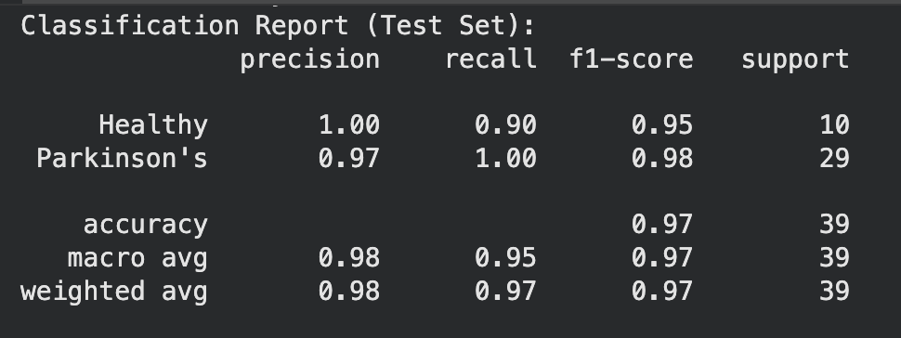

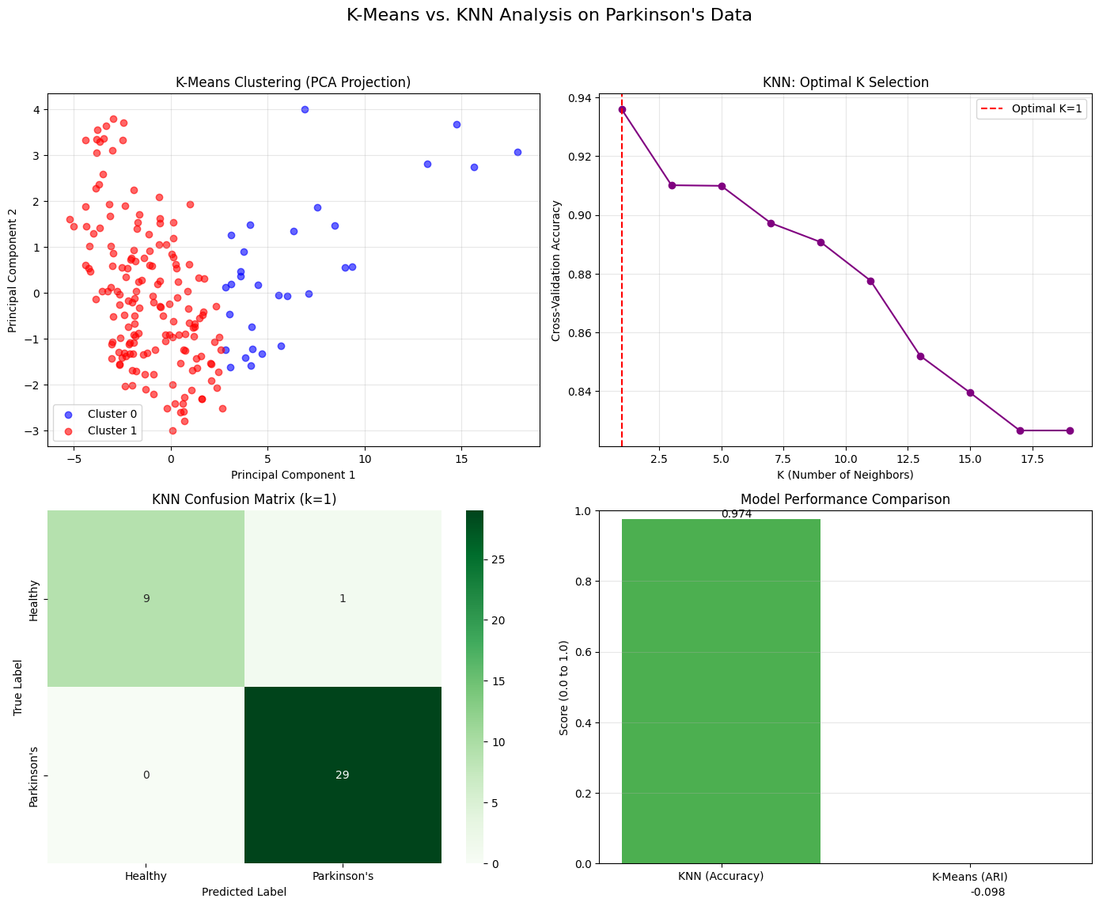

Learning Outcomes:

